REPORT ON DOMESTIC JUNIOR RESEARCHER EXCHANGE PROGRAM

(Name, Affiliation, Supervisor, Host researcher of the destination, Term)
Trang Xuan Chi
D2, Department of Physics, Tohoku University
Supervisor: Takafumi Sato (Professor, Department of Physics, Tohoku University)
Host researcher of the destination: Kouji Segawa(Professor, Department of Physics, Kyoto Sangyo University)
Term: 2017/12/04-2017/12/15

(Overview)
Three-dimensional topological insulators (3D TIs) represent a new state of quantum matter with an insulating bulk band and a conducting surface state. The discovery of TIs stimulated the search for a more exotic state of matter, the topological superconductors (TSCs). My current research topic in our lab is a realization of topological superconductor (TSC) through the fabrication of a junction between superconducting ultrathin film and topological insulators (TIs) and an evaluation of electronics states by ARPES. To obtain a good junction, it is essential to fabricate high-quality TI single crystals. Since Prof. Segawa at Kyoto Sangyo University is an expert of single crystal synthesis, it was a great pleasure to visit Segawa lab. and fabricate TI single crystal samples which will be used for my ARPES measurements.

(Detailed report)
During my stay at Segawa lab., under Prof. Segawa’s careful instruction, I studied how to fabricate big single crystals of 3D TI TlBiSe₂ and TlBiS₂ by Bridgman method, e.g. weighing raw materials (shown in Fig 1(a)) in a glove box, sealing the glass tube for preventing degradation of raw materials in the air, and optimizing growth condition. After obtaining big single-crystal materials as shown in Fig. 1 (b), I characterized it by transport and X-ray powder diffraction (XRD) measurements to confirm the high quality (The preparation for the transport measurement is shown in Fig. 1(c)). At the end of my exchange program, I received totally two big single crystals of TlBiS₂ and one of TlBiSe₂ which will be very useful for my ARPES experiments. Furthermore, I also had a fruitful discussion about our recent study of new bulk-insulating TI Tl(Bi_{1-x}Sb_{x})Te₂ [1] with Segawa’s lab. members and Faculty of Physics’ members.

My visit to Segawa’s lab. provided me opportunities to visit the available facilities, practice synthesizing single crystals of TIs, carry out transport and XRD measurements, and possess valuable discussions. It’s very important for my current research.

Finally, I would like to thank TMS project for giving such opportunities and Prof. Segawa for kindly and patiently teaching during my stay.

[1] C. X. Trang et al., Phys. Rev. B 93 165123 (2016)
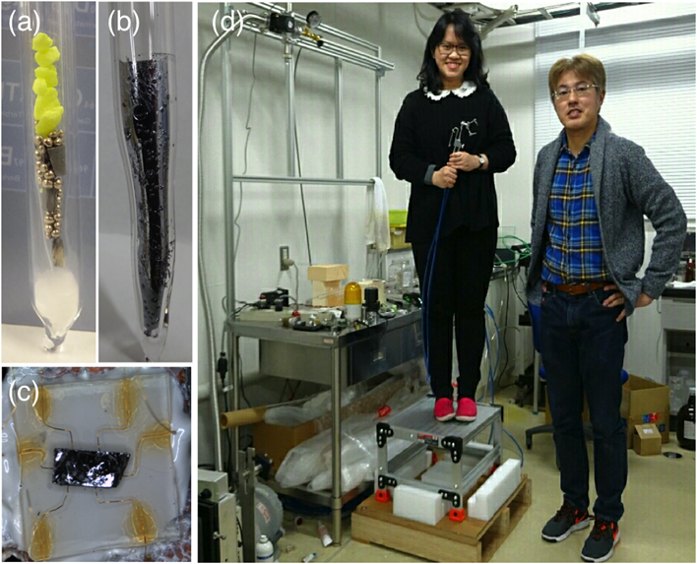
(Attach photo)

(Photo caption)
Figure 1: (a) Raw materials. (b) A big single crystal. (c) A sample with six welded contacts, preparing for transport measurements. (d) Prof. Segawa (right) and me at actual experimental area.

