REPORT ON RESEARCHER EXCHANGE PROGRAM

(Name, Affiliation, Host researcher of the destination, Term)
Alexander Golubov
Associate Professor, Twente University & Moskow Institute of Physics and Technology
Host researcher of the destination:
Yasuhiro Asano (Associate Professor, Department of Applied Physics, Hokkaido University)
Term: 2017/03/20-2017/03/31

(Overview)
2017年3月20日から31日までの12日間、Twente大学（モスクワ物理工学校）Alexander Golubov准教授（教授）が本新学術領域のREPプログラムで、北海道大学、名古屋大学(京都大学)に滞在され、奇周波数クーパー対、スピン3重項超伝導接合に関して浅野（A班分担）、田仲（B班分担）、前野（A班代表）と有意義な議論が行われました。

ルテニウム酸化物はカイラルｐ波スピン三重項超伝導体の有力な候補物質であり、その表面にはトポロジカルに守られたマヨラナ状態と奇周波数クーパー対が存在し、超伝導体の電磁気学的な応答に異常をもたらす事を、我々は理論的に明らかにしていました。ロシアのチェルノゴロフカにある物性研において、ルテニウム銅酸化物の微小単結晶を用いて表面インピーダンスの測定を行っています。これまでに、通常の超伝導体とは質的に異なる実験データが得られはじめています。この実験結果を解釈するためにはどのような理論計算を行い、何に焦点を当てて議論すればよいか、を話し合いました。

またルテニウム酸化物と金属超伝導体のジョセフソン接合やルテニウム酸化物を用いたSQUID（超伝導量子干渉素子）の研究が産総研で行われています。この実験を解釈するため、物質の多バンド性やスピン起動相互作用の効果を取り入れた場合のジョセフソン電流の振る舞いに関して理論の論文を投稿中です。Golubov氏と議論することで論文改訂の方針を決めました。数値計算結果をうまく再現するようなモデルと現象理解のための簡潔な物理描像の構築に関して議論を行いました。

(Detailed report)
The scientific program started from the visit to Hokkaido University and discussions with Prof. Asano and the members of his group on various problems including odd-frequency pairing in superconducting structures, surface impedance of unconventional superconductors and Josephson effect in multiorbital model of SrRuO4. Two manuscripts on these problems are currently in preparation.

On March 22 I gave a seminar at Hokkaido University on “Proximity induced topological superconductivity: Andreev bound states and odd-frequency pairing”. I gave an overview of hybrid Proximity induced topological superconductivity: Andreev bound states and odd-frequency pairing in structures involving superconducting junctions on surfaces of topological insulators and to the results of recent experimental and theoretical studies. I have presented the results of recent theoretical and experimental studies of proximity effect in a topological insulator (TI) Bi1.5Sb0.5Te1.7Se1.3 in direct contact with an s-wave superconducting Nb electrode, performed in Twente University and in Moscow Institute of Physics and Technology.

During the week March 27 - 31 I visited the group of Prof. Tanaka at Nagoya University. During this time I had many discussions with him, with Dr. Yada and with PhD student Hashimoto on problems related to extension of the circuit theory in unconventional superconducting junctions, interplay of Rashba spin-orbit interaction and Zeeman effect in SNS structures and on Josephson effect in multiorbital model of SrRuO4. The manuscript is currently in preparation.

During my stay in Nagoya I visited Kyoto University on March 29. Within the first half of the day I had discussions with Prof. Maeno and several members of his group about their recent experimental results on detection of spin-triplet superconductivity in mesoscopic structures Au/ferromagnetic SrRuO3/ superconducting Sr2RuO4. We have discussed possible theoretical interpretations of these data and relevant models which may help to identify spin-triplet proximity effect in these junctions.

Then at 14:00-15:00 I gave a talk at the TMS seminar at Yukawa Institute on the topic “Physics of Andreev bound states and odd-frequency pairing”. I have presented overview of the physics of Andreev bound states in superconducting junctions with various types of symmetry of superconducting order parameter with special attention to the relation between Andreev bound states and the odd-frequency pairing. I summarized the theory of the odd-frequency pairing and discussed its implications in experiments. After the seminar I had further discussions with Prof. Sato from Yukawa Institute and with Prof. Tanaka.

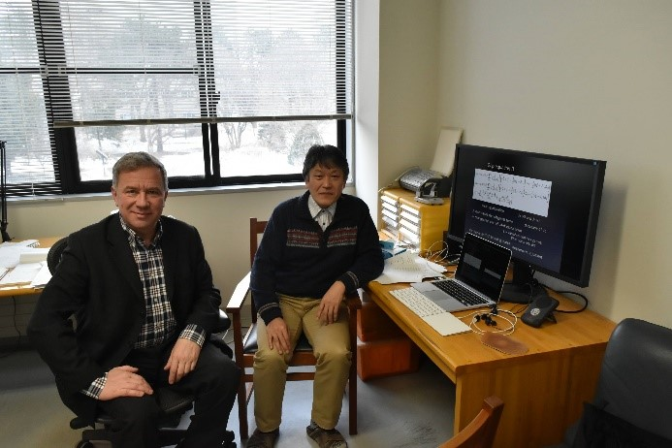
(Attach photo)
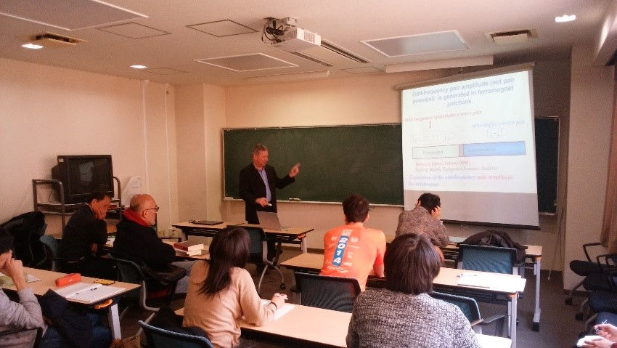
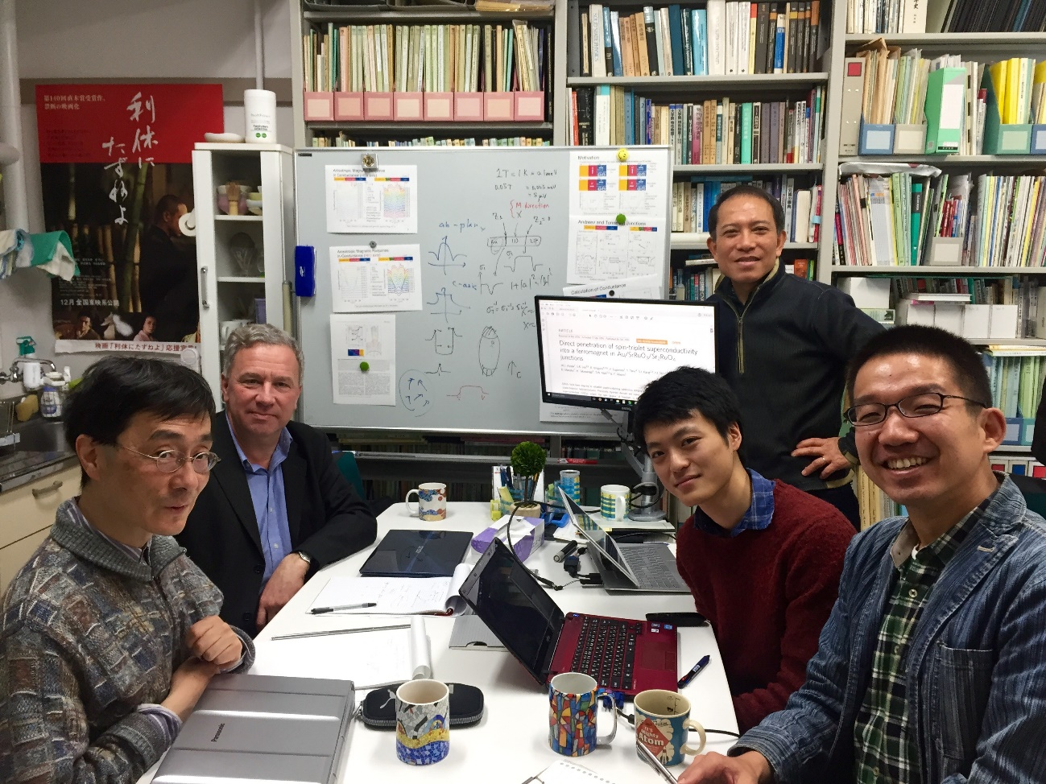
(Photo caption)
- From left: Alexander Golubov, Yasuhiro Asano.
- Lecture landscape
- .From left: Yukio Tanaka, Alexander Golubov, Kunieda Masanao, Yoshiteru Maeno, and Shingo Yonezawa

