REP報告

（招聘についての情報）
招聘滞在者：James Sauls教授、ノースウェスタン大学
受入研究者：水島 健 (D01)、大阪大学 大学院基礎工学研究科
期間：2016年11月1日（火）〜11月22日（火）

（概要）
REPプログラムを利用して、2016年11月1日から3週間Sauls教授に大阪大学を中心に滞在していただきました。Saulsさんとは2012年にNorthwestern大学へ半年間滞在してからの縁で、それから毎年研究室に短期滞在し、共同研究をすすめてきました。2016年の秋セメスターでは授業がないということでしたので、良い機会と思い、滞在していただくことになりました。本人より感想を含む詳細な報告をいただきました。
（招聘滞在者による報告）
I arrived in Osaka on the 1st of November and spent the first week at Osaka University discussing a collaboration on the Bosonic mode spectrum of the topological B-phase of superfluid ³He with Professor Mizushima. I also had the opportunity to discuss several topics with Professors Fujimoto and Mizushima related to the topological properties of chiral superconductors. Of particular interest to me was learning about the connection between torsion and chiral anomalies from Professor Fujimoto. This led me to realize that recent work by my graduate student, Josh Wiman, predicting the existence of a new topological spiral ordered phase of ³He in 100 nm pores with spontaneous current flow on the boundaries is likely a realization of a torsion induced chiral anomaly. I am pursuing this as a result of these discussions. Professor Mizushima also arranged discussions with Dr. Kazushi Aoyama at Osaka Univerity on the properties on superfluid ³He in confined geometries, as well as the Bosonic spectrum of multi-component superconductors which are being pursued by Professor Mizushima and Professor Fujimoto as well as my group at Northwestern. Out of these discussions developed a plan to pursue research into the Bosonic spectrum in non-centro-symmetric superconductors with Professors Aoyama and Mizushima.

Early in my visit I had the opportunity to visit Kyoto University to give the TMS Seminar on “Anomalous Hall Effects in Chiral Superfluids” and to learn about recent work in Professor Maeno’s laboratory as well as Professors Ishida and Matsuda. Several students asked me questions during the discussion period. During the visit I learned quite a lot about experiments and the interpretation of the newly discovered nematic superconducting phase of Cu_{x}Bi₂Se₃. I had two detailed conversations with Professor Maeno on heat transport in Sr₂RuO₄ and its possible implications for the paring symmetry in this unconventional superconductor. The Kyoto visit also allowed me the opportunity to meet and talk with Professor Kawakami heading the TMS project. Professors Kawakami and Maeno treated me to exceptional hospitality, Japanese cuisine and culture!

In the second week of my visit I had the opportunity to give a pedagogical seminar titled “From Spontaneous Symmetry Breaking to Topological Order” at Osaka University, Department of Materials Engineering Science. This was followed by a unique opportunity to appreciate the specialties of Osaka, to discuss the passion we all have for the sport of baseball as well as physics! During this second week I worked on a manuscript with Professor Mizushima on the masses of the Bosonic modes of the B-phase, more specifically on the mass shifts due to vacuum polarization effects. The parent vacuum is Fermionic, and thus particle-hole and particle-particle interactions lead to polarization induced mass shifts for Bosonic modes with different symmetry than that of the vacuum. These mass shifts lead to violations of Nambu's conjectured sum rule for the class of Nambu-Jona-Lasino theories for Bosonic and Fermionic mass generation by spontaneous symmetry breaking. In this paper we also develop a Lagrangian field theory for the Bosonic spectrum. While this formulation is formulated by integrating out the Fermionic degrees of freedom, and thus cannot include vacuum polarization corrections, it has the advantage of allowing including leading order strong coupling effects and allows us to extend the theory of the Bosonic spectrum to confined topological ³He-B. This is a basis for our continuing collaboration to investigate the signatures of the surface Majorana spectrum in the reflection and absorption spectrum of spin J=2 Higgs modes in ³He-B. This work is accepted for publication in Physical Review B pending minor revisions.

In the third part of my visit I had the opportunity to visit Professor Tanka and his group at Nagoya University. I had the opportunity to a research seminar on “Anomalous Hall Effects in Chiral Superfluids” and to hear about the broad range of research going on in Professor Tanaka’s group, including discussions on the concept of “odd-frequency superconductivity”, a major them of Tanaka-san’s research. I had the opportunity to learn of the work by Professor Kawaguchi on novel ground states of dipolar BECs and cold atoms, as well Professor Kontani’s research on the theory of strong correlations in Fe-based superconductors. From Nagoya I moved to Keio University to participate in a joint workshop of the TMS project and the Topological Science Project hosted by Professor Nitta of Keio University termed the TMS Intensive-Interactive workshop. Indeed it was both intensive and interactive, and an excellent workshop with a broad range of theoretical ideas and results presented in topological materials to the role of topology and spontaneous symmetry breaking in quantum field theory. This was one of the best cross-disciplinary workshops I have participated in. I learned a lot, particularly about theoretical directions of colleagues in Japan – from topological insulators to neutrinos. I also came away with a deeper sense of the focus and interactions within the physics community in Japan. It was a great opportunity for me, and as a result I expect there will be continuing research collaborations with colleagues in Japan for which I am eager to contribute.

（受入研究者による報告）
Saulsさんには大阪・京都・名古屋と3度もTMSセミナーを行っていただき、さらに集中連携研究会（慶應）でも講演をしていただきました。タイトなスケジュールにもかかわらず、教育的なイントロを含む質の高い講演をしていただき、感謝に堪えません。TMSセミナーでは、前野新学術領域の大きな成果の一つである「超流動³He-Aにおけるカイラリティの直接観測」に関する理論が主なトピックでした。カイラリティの直接観測という美しい実験結果と、それに定量的に合致した美しい理論を軸にしながら、UPt₃など関連した超伝導物質に対する新たな知見も含んだ講演は圧巻でした。Saulsさんはもともと中性子星に関するテーマでPh.D.を取得され、その後、超流動³Heから超伝導物質へと様々な研究分野を渡り歩かれています。その経歴もあってか、素粒子や宇宙など異分野の方々が集まった慶應での研究会も満喫され、異分野・異文化交流を楽しまれたようです。
日本に到着された数日後にワールドシリーズの最終戦をともに観戦し、その結果にカブスの熱狂的ファンであるSaulsさんは歓喜していました。ただ、その次の週の大統領選挙の結果に打ちひしがれ、まさに天国と地獄を味わったようです。民主党はブルーカラー有権者に支持のあるサンダース氏を候補にしなかったのが敗因だと分析しながら、立ち直れないほどに項垂れている姿が印象に残っています。また本人が「自分の人生の9割は物理で、残りは自転車だ」というほどのサイクリストで、滞在中は愛用のロードバイクをアメリカより持参されていました。セミプロというほどのレベルなので、とても一緒にはついていけませんでしたが、秋の深まる箕面や能勢のワインディングロードを楽しまれたようです。
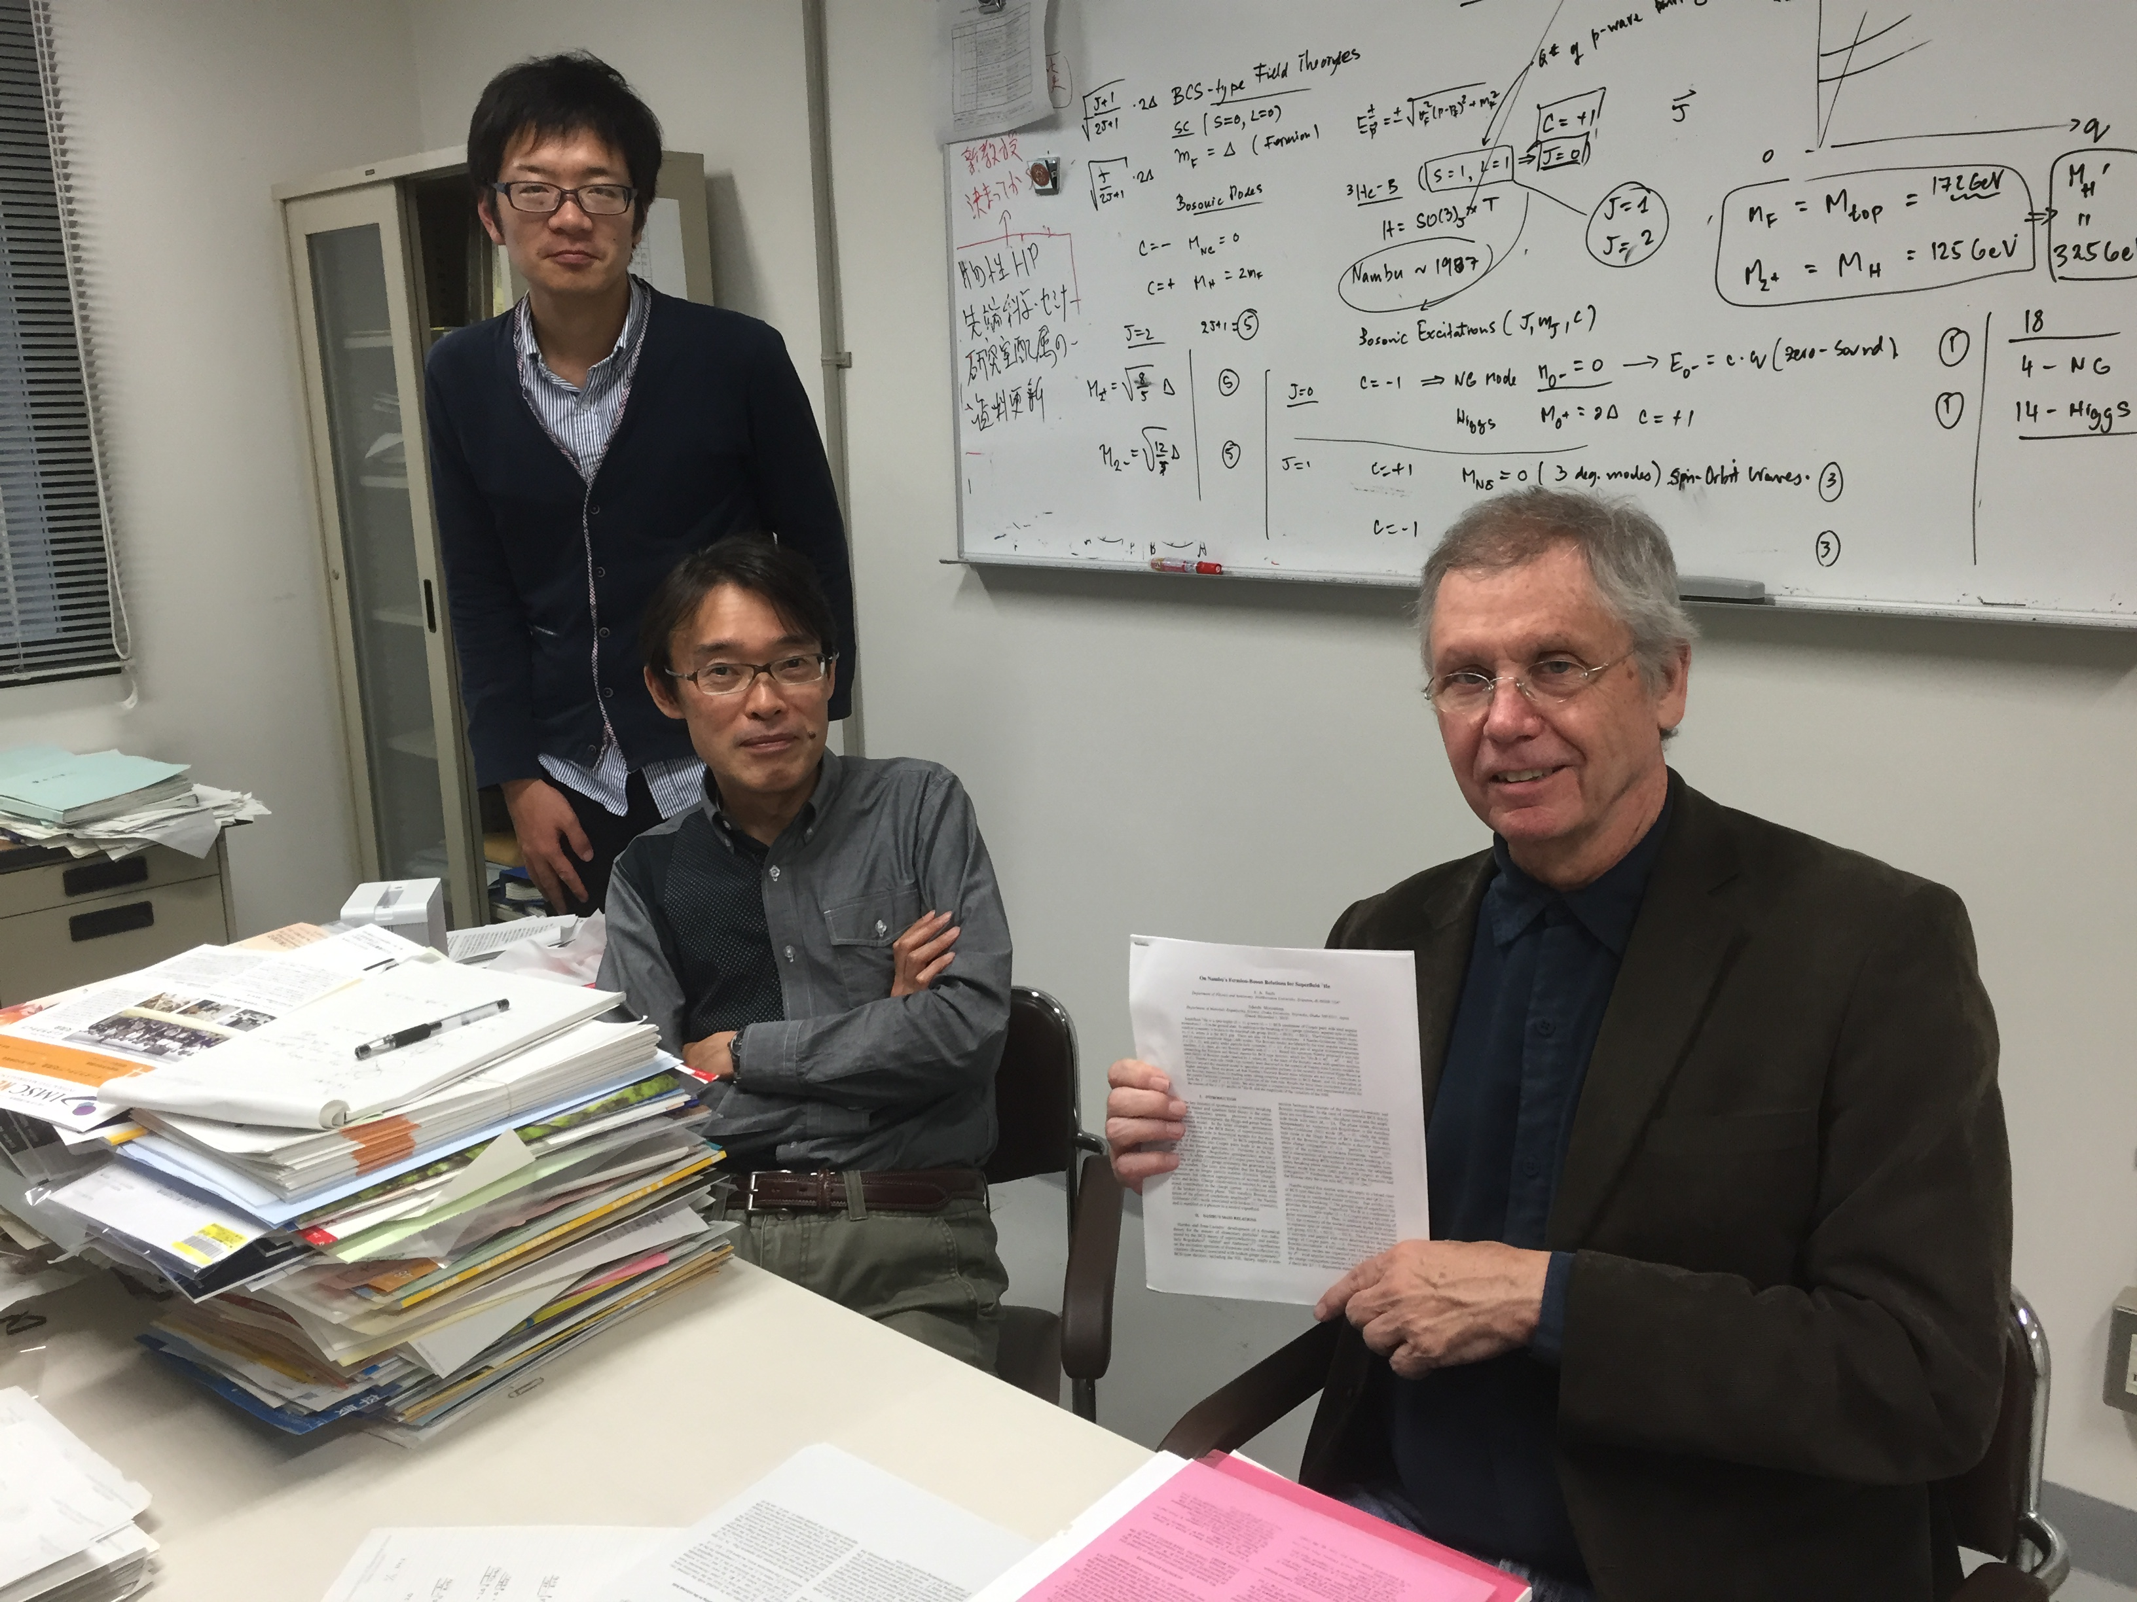
（写真）
（写真のキャプション）
大阪大学にて藤本教授（A01）と植松氏と議論。
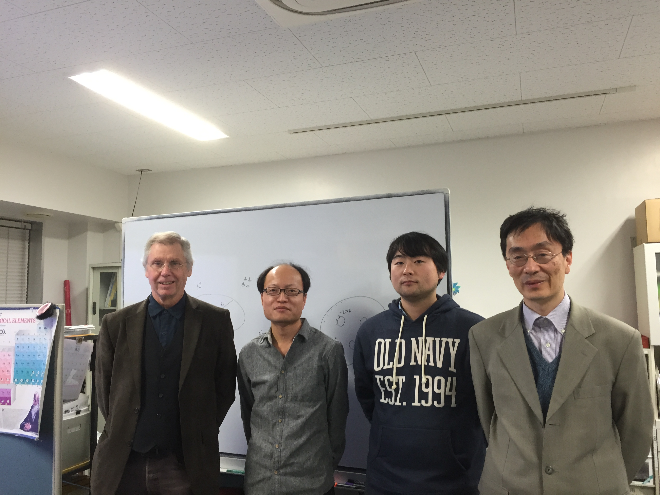
名古屋大学にて田仲グループ（B01）との議論

