REPORT ON JUNIOR RESEARCHER EXCHANGE PROGRAM

(Name, Affiliation, Supervisor, Host researcher of the destination, Term)
Jan Niklas Hausmann
Master-course graduate student of Humboldt University, Berlin, Germany
Supervisor: Nicola Pinna ((Professor, Institut für Chemie, Humboldt-Universität zu Berlin)
Host researcher of the destination: Yoshiteru Maeno (Professor, Department of Physics, Kyoto University)
Term: 2016/10/20-2016/12/04

(Overview)
“Synthesis of the superconducting Dirac-metal antiperovskite oxide Sr3-xSnO”

I stayed at the Quantum Materials laboratory of Prof. Yoshiteru Maeno in Kyoto University for 46 days from 20 October to 4 December, 2016. My major is chemistry and I participated in the synthesis of the recently in this group discovered antiperovskite oxide superconductor Sr3-xSnO. Sr3-xSnO is the first superconductor among antiperovskite oxides and it contains slightly gapped three-dimensional Dirac cones at its Fermi level, owing to an energy level inversion of the Sn-5p and Sr-4d. It is predicted to be a candidate for a topological crystalline insulator, protected by mirror symmetry.
(Detailed report)
It was a very fascinating experience for me to work in a solid state physics laboratory and I enjoyed to work on the synthesis of a material with such a big potential. I experienced differences in the approach of chemists and physicists. As a chemist I was always focused completely on the purity and crystallinity of a material. These parameters are doubtlessly important for physicist, too. However, for physicist in the centre of investigation are different properties like in this case superconductivity and it was interesting to experience the significant effect of comparably small changes in synthesis parameters on the superconducting properties. Therefore, to perform research on such a material, I, as the synthesising chemist, had to work very close together with the investigating physicist, mainly Mohamed Oudah, of the group. I believe this worked well across the cultural barriers during my stay in the Quantum Materials laboratory. At least I learned a lot from my Japanese and international physicist colleagues and I believe the materials I produced will be useful for them, too.

The supervision of Prof. Yoshiteru Maeno and Prof. Shingo Yonezawa was excellent and very intensive with one meeting on this research subject a week and an additional weekly seminar on solid state physics. My knowledge of superconductivity and solid state physics in general evolved substantially during my stay. In conclusion, I really enjoyed my stay in the Quantum Materials laboratory and believe it was a fruitful exchange for both sides.
(A note from the host researcher: The work Niklas made the substantial contribution was published as Nature Communications 7, 13617 (12 December, 2016).)

(Attach photo)
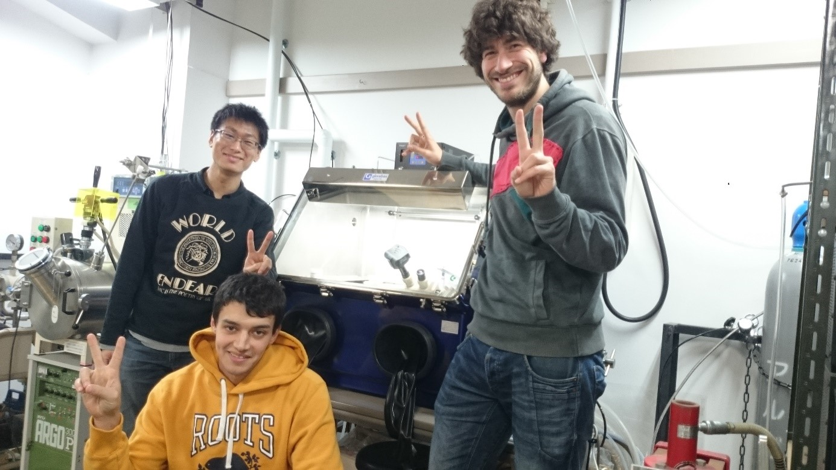
(Photo caption)
From left: Atsutoshi Ikeda, Mohamed Oudah, and Jan Niklas Hausmann, in front of the glove box used in this work.

